Sistemas Informáticos (Computer Systems)
Unit 01. Activities 02 - Solution



Authors: Sergi García, Alfredo Oltra
Updated September 2023

Unit 01. Activities 02 - Solution

Exercise 01 - Solution
Memory state:
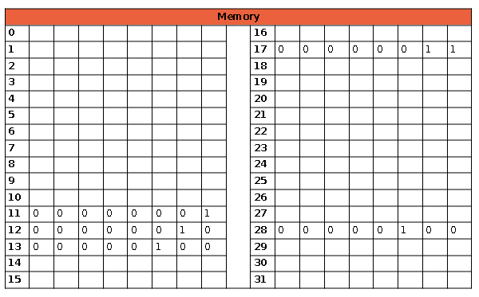
Register state:
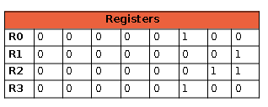
Instructions explanation:
00001011 Write in memory position 11
(A) [01010101] Write 1
00001100 Write in memory position 12
(B) [00100001] Write 2
00010001 Write in memory position 17
(C) [00000010] Write 3
00011100 Write in memory position 28
(D) [00101101] Write 4
01001011 Copy the data from memory position 11 to register 0
10000100 Copy the data from Register 0 to Register_1: 1 → in R1
01011100 Copy the data from memory position 28 to register 0
10001100 Copy the data from Register 0 to Register_3: 4 → in R3
01010001 Copy the data from memory position 17 to register 0
10001000 Copy the data from Register 0 to Register_2: 3 → in R2
10111110 Multiply the content of R3 and R2 and write the result in R3 [3*4] → 12 in R3
10101101 Subtract the content of R3 and R1 and write the result in R3 [12‐1] → 11 in R3
01001100 Copy the data from memory position 12 to Register_0
10001000 Copy the data from Register 0 to Register_2: 2 → in R2
10011110 Add the content of R3 and R2 and write the result in R3 [2 + 11] → 13 ¡n R3
01010001 Copy the data from memory position 17 to Register_0
10001000 Copy the data from register_0 to register_2 → 3 in R2
11001110 Divide the content of R3 by R2 and write in R3 [13/3] 4 in R3
10000011 Copy the date from R3 to R0 → 4 in R0
01101101 Write in memory position 13 the content of Register 0
00101101 Show in the screen the content of memory position 13

Solution to questions:
- Formula: ((D*C)‐A+B)/C.
- 4 (Content of memory position 13).
- The state shown in the solution.
- If the PC was initially at 258, and we have executed 21 instructions, the PC will contain the value 279.
- We have two bits, i.e. 4 registers.

